Project Report

|  |  |
| --- | --- |
| **Team ID** | **PNT2022TMID44647** |
| **Project Name** | **Smart waste management system for metropolitan cities** |
| **Team Lead** | **KARTHIK. E** |
| **Team Member 1** | **YUVARAJ. M** |
| **Team Member 2** | **SAKTHIVEL.P** |
| **Team Member 3** | **DINESH. A** |
| **Team Member 4** | **CHANDRU. S** |

# INTRODUCTION

## Project Overview:

Our waste generation is constantly growing to form a [global garbage crisis. E](https://evreka.co/blog/global-garbage-crisis-and-high-tech-solutions/)ven though we indulge in creating a more sustainable and greener, we still fail to handle our waste generation and management. Combining technology support with a vision of social, economic and environmental sustainability is the best way out of this problem. It is done in the following manner. The smart bin system undergoes a thorough system check and battery level monitoring in order to function efficiently. If the battery level is found to be low, it has to be recharged immediately, else it can proceed to the next step. The threshold level levels of the bin are indicated my multiple sensors attached to bin. If the garbage exceeds the level, then an alert message is sent to the garbage collectors as well as to the municipality or area administration. The area in which garbage is found to overflow is allocated to respective garbage collectors in the form of messages through GSM system. Once the waste bin is emptied, an information update is sent to the municipality and server is updated. This is how the waste from bins can be efficiently handled and managed using technology which in turn keeps the environment clean and healthy.

## Purpose:

We amalgamate technology along with waste management in order to effectively create a safe and a hygienic environment. Smart waste management is about using technology and data to create a more efficient waste industry. Based on IoT (Internet of Things) technology, smart waste management aims to optimize resource allocation, reduce running costs, and increase the sustainability of waste services. This makes it possible to plan more efficient routes for the trash collectors who empty the bins, but also lowers the chance of any bin being full for over a week. A good level of coordination exists between the garbage collectors and the information supplied via technology. This makes them well aware of the existing garbage level and instigate them whenever the bins reach the threshold level. They are sent with alert messages so that they can collect the garbage on time without littering the surrounding area. The fill patterns of specific containers can be identified by historical data and managed

accordingly in the long term. In addition to hardware solutions, mobile applications are used to overcome the challenges in the regular waste management system, such as keeping track of the drivers while they are operating on the field. Thus, smart waste management provides us with the most optimal way of managing the waste in an efficient manner using technology

# LITERATURE SURVEY:

## Existing problem:

Waste management has become an alarming challenge in local towns and cities across the world. Often the local area bins are overflowing and the municipalities are not aware of it. This affects the residents of that particular area in numerous ways starting from bad odour to unhygienic and unsafe surroundings. Poor waste management - ranging from non-existing collection systems to ineffective disposal -causes air pollution, water and soil contamination. Open and unsanitary areas contribute to contamination of drinking water and can cause infection and transmit diseases. Toxic components such as Persistent Organic Pollutants (POPs) pose particularly significant risks to human health and the environment as they accumulate through the food chain. Animals eating contaminated plants have higher doses of contaminants than if they were directly exposed. Precipitation or surface water seeping through waste will absorb hazardous components from landfills, agricultural areas, feedlots, etc. and carry them into surface and groundwater. Contaminated groundwater also poses a great health risk, as it is often used for drinking, bathing and recreation, as well as in agricultural and industrial activities. Landfills and waste transfer stations can attract various pests (insects, rodents, gulls, etc.) that look for food from waste. These pests can spread diseases through viruses and bacteria (i.e., salmonella and e-coli), which are a risk to human health.

## References:

**PAPER 1:**

**TITLE:** IoT Based Waste Management for Smart City **AUTHOR NAME:** Parkash Tambare, Prabu Venkatachalam **PUBLICATION YEAR:** 2016 **DESCRIPTION:**

In the current situation, we frequently observe that the trash cans or dust cans that

are located in public spaces in cities are overflowing due to an increase in the amount of waste produced each day. We are planning to construct “IoT Based Waste Management for Smart Cities” to prevent this from happening because it makes living conditions for people unsanitary and causes unpleasant odours in the surrounding area. There are numerous trash cans scattered throughout the city or on the campus that are part of the proposed system. Each trash can is equipped with a low-cost embedded device that tracks the level of the trash cans and an individual ID that will enable it to be tracked and identified.

## PAPER 2:

**AUTHOR NAME:** Mohammad Aazam, Marc St-Hilaire,

Chung-Horng Lung, Ioannis Lambadaris

## PUBLICATION YEAR: 2016 DESCRIPTION:

Each bin in the Cloud SWAM system that Mohammad Aazam et al suggested has sensors that can detect the amount of waste inside. There are separate bins for organic, plastic/paper/bottle/glass, and metal waste. This way, each form of waste is already divided, and it is known how much and what kind of waste is collected thanks to the status. Different entities and stakeholders may benefit from the accessibility of cloud-stored data in different ways. Analysis and planning can begin as soon as garbage is collected and continue through recycling and import/export-related activities. Timely garbage collection is provided via the Cloud SWAM system. A timely and effective method of waste collection improves health, hygiene, and disposal.

## PAPER 3:

**TITLE:** Arduino Microcontroller Based Smart Dustbins for Smart Cities **AUTHOR NAME:** K. Suresh, S. Bhuvanesh and B. Krishna Devan **PUBLICATION YEAR:** 2019 **DESCRIPTION:**

In this paper, a technique for cleaning up our surroundings and environment is

described. The Indian government just began work on a smart city initiative, and in order for these towns to be smarter than they already are, the garbage collection and disposal system must be improved upon. Self-Monitoring Automated Route Trash (SMART) dustbins are intended for use in smart buildings such as colleges, hospitals, and bus stops, among other places. In this study, we have employed the PIR and Ultrasonic sensors to detect human presence, the Servomotor to open the dustbin lid, and the Ultrasonic sensor to detect the level of rubbish. Signals between two trash cans are transmitted using a communication module, and the GSM module sends the message to the operator.

## PAPER 4:

**AUTHOR NAME:** Mohd Helmy Abd Wahab, Aeslina Abdul Kadir,

Mohd Razali Tomari and Mohamad Hairol Jabbar

## PUBLICATION YEAR: 2014

**DESCRIPTION:**

Proposed a smart recycle bin that can handle the recycling of plastic, glass, paper, and aluminium cans. It generates a 3R card after automatically determining the value of the trash thrown away. The recycle system makes it possible to accumulate points for placing waste into designated recycle bins. By allowing the points to be redeemed for goods or services, such a system promotes recycling activities. The system keeps track of information on disposal procedures, materials disposed of, user identification, and points accrued by the user. To use the recycle bin, the user must tap his card to the designated RFID reader. Doors to recycling bins are opened, and rubbish is placed one by one.

## PAPER 5:

**TITLE:** Waste Management Initiatives in India For Human Wellbeing **AUTHOR NAME:** Dr. Raveesh Agarwal, Mona Chaudhary and Jayveer Singh **PUBLICATION YEAR:** 2015 **DESCRIPTION:**

The objective of this paper is to examine the present methods used in India for the

welfare of its people in different waste management efforts. The other goal is to offer advice on how to make Indian municipalities' trash disposal procedures better. On secondary research, this essay is founded. The system is improved by looking at the reports that have already been written about waste management and the suggestions made for improvement by planners, NGOs, consultants, government accountability organisations, and important business leaders. It provides in-depth understanding of the various waste management programmes in India and identifies areas where waste management might be improved for societal benefit. The essay makes an effort to comprehend the crucial part that our nation's official waste management sector plays in the waste management process.

* 1. **Problem Statement Definition:**

|  |  |  |  |  |  |
| --- | --- | --- | --- | --- | --- |
| **Problem Statement (PS)** | **I am (Customer)** | **I am trying to** | **But** | **Because** | **Which makes me**  **feel** |
| PS-1 | Council | Monitor the waste in my city | I have not much effective system for  monitoring | Because of high cost | unhygienic |
| PS-2 | Council | Manage the waste in my city | I have not much effective  system for  managing | Because of more time consuming | unsafe |

# IDEATION & PROPOSED SOLUTION:

## Empathy map canvas:

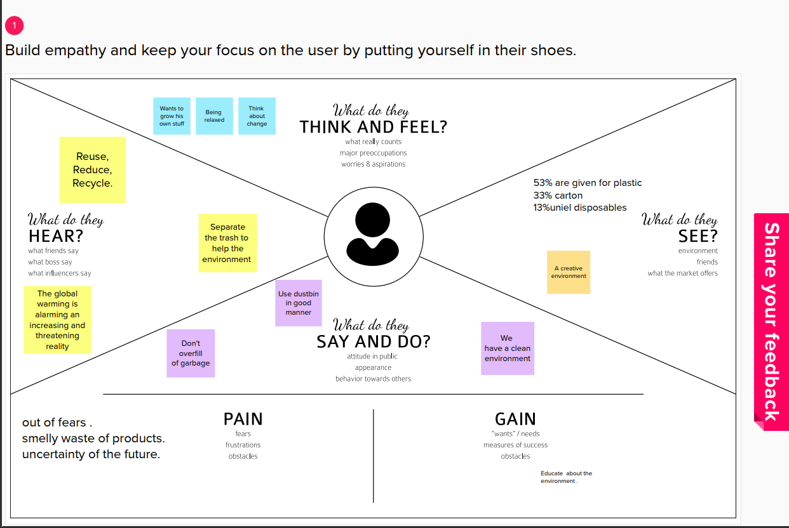

* 1. **Ideation & Brainstorming:**

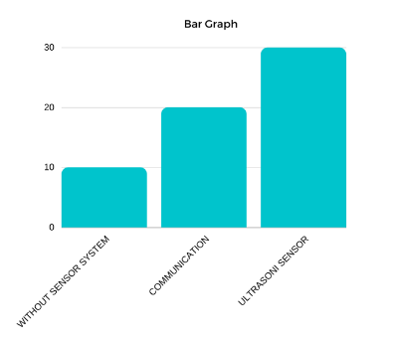

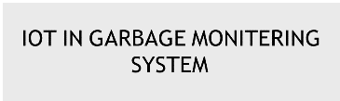

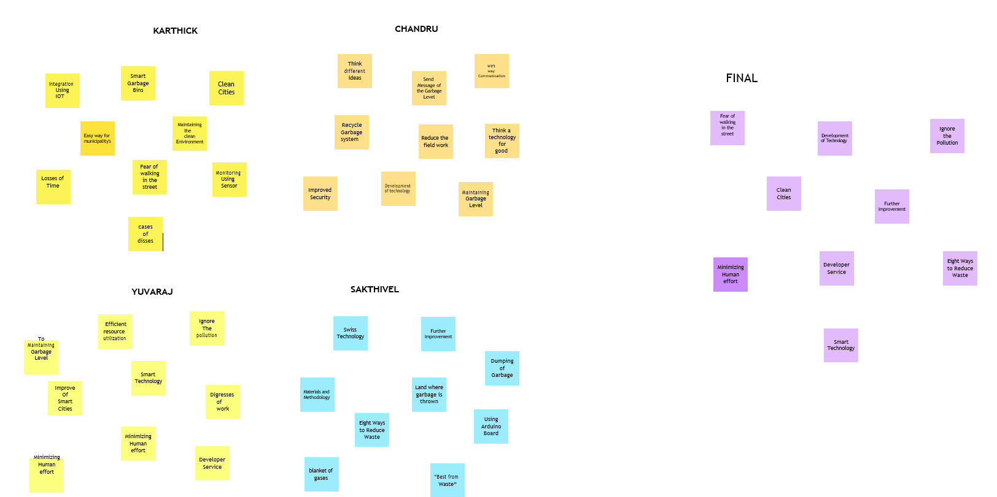

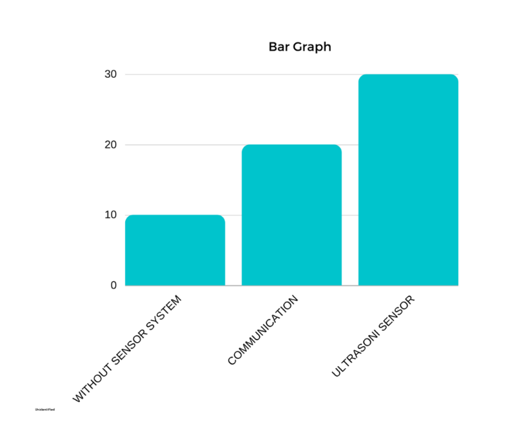

## Proposed Solution:

|  |  |  |
| --- | --- | --- |
| **SI No.** | **Parameter** | **Description** |

|  |  |  |
| --- | --- | --- |
| 1. | Problem Statement (Problem to be solved) | Detecting the level of garbage and informing the garbage collectors through a proper communication channel about the garbage level and alerts them to collect it at a  specified time efficiently. |
| 2. | Idea / Solution description | By using fill level sensors we can detect the garbage level. Improving the communication channel using proper technology like WiMAX. Using GPS for tracking the location of bin and sorting out the short routes.  Using cloud service for the storage purpose. |
| 3. | Novelty / Uniqueness | By using IoT, GPS and GSM like technologies which if properly used in the establishment of this project helps to detect the garbage level and intimating about it to the authority and initiating them to collect the garbage on  time. |
| 4. | Social Impact / Customer Satisfaction | It keeps our surroundings clean and green and free from bad odour of wastes, emphasizes on healthy environment.  Reduces air pollution |
| 5. | Business Model (Revenue Model) | Smart waste management system is an innovative and effective step to analyze the production of waste annually and it helps to find the ways to reduce the factors which  increases the waste produced. |
| 6. | Scalability of the Solution | Smart waste management can attain its scalability by still more advancement in IoT and using many sensors to detect its accurate level accurately. Its implementation can be enhanced by using 5G type of technology for faster communication. AI recycling robots can be  used in the nearer future. |

* 1. 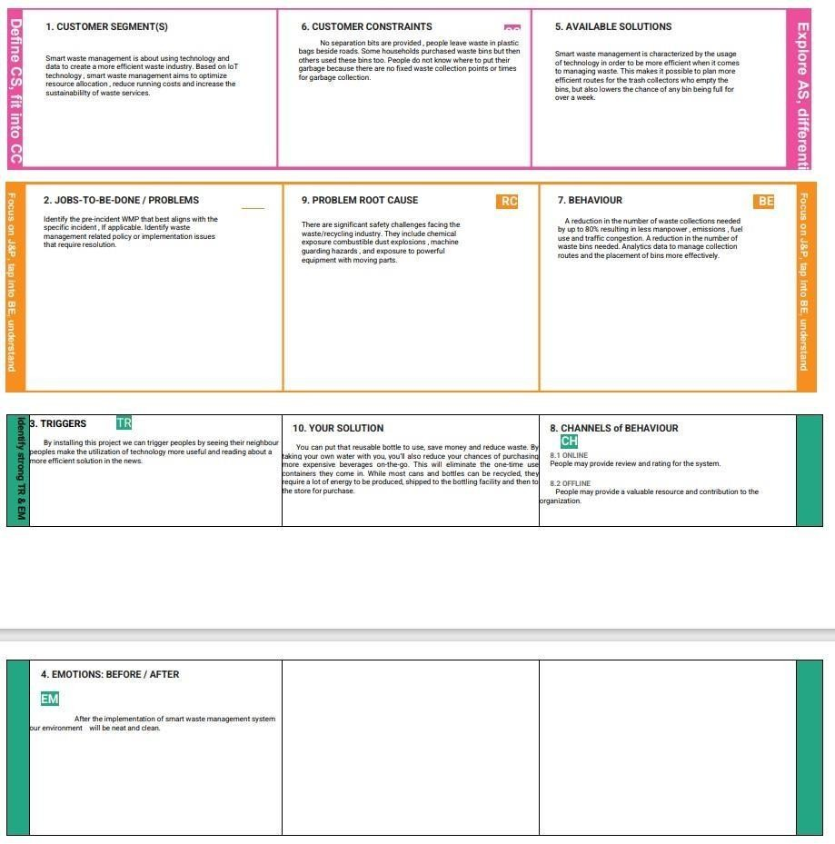**Problem solution fit:**

# REQUIREMENT ANALYSIS

**Functional Requirements:**

Following are the functional requirements of the proposed solution.

|  |  |  |
| --- | --- | --- |
| **FR No.** | **Functional Requirement (Epic)** | **Sub Requirement (Story / Sub-Task)** |
| FR-1 | Detailed bin inventory. | All monitored bins and stands can be seen on the map, and you can visit them at any time via the Street View feature from Google. Bins or stands are visible on the map as green, orange or red circles. You can see bin details in the Dashboard – capacity, waste type, last measurement, GPS location and collection schedule or pick recognition. |
| FR-2 | Real time bin monitoring. | The Dashboard displays real-time data on fill-levels of bins monitored by smart sensors. In addition to the % of fill-level, based on the historical data, the tool predicts when the bin will become full, one of the functionalities that are not included even in the best waste management software.. Sensors recognize picks as well; so you can check when the bin was last collected. With real-time data and predictions, you can eliminate the overflowing bins and stop collecting half-empty ones. |
| FR-3 | Expensive bins. | We help you identify bins that drive up your collection costs. The tool calculates a rating for each bin in terms of collection costs. The tool considers the average distance depo-bindischarge in the area. The tool assigns bin a rating (1-10) and calculates distance from depo-bin discharge. |
| FR-4 | Adjust bin distribution. | Ensure the most optimal distribution of bins. Identify areas with either dense or sparse bin distribution.  Make sure all trash types are represented within a stand. Based on the historical data, you can adjust bin capacity or location where necessary. |
| FR-5 | Eliminate unefficient picks. | Eliminate the collection of half-empty bins. The sensors recognize picks. By using real-time data on fill-levels and pick recognition, we can show you how full the bins you collect . The report shows how full the bin was when picked. You immediately see any inefficient picks below 80% full. |
| FR-6 | Plan waste collection routes. | The tool semi-automates waste collection route planning. Based on current bin fill-levels and predictions of reaching full capacity, you are ready to respond and schedule waste collection.  You can compare planned vs. executed routes to identify any inconsistencies. |

**Non-functional Requirements:**

Following are the non-functional requirements of proposed solution

|  |  |  |
| --- | --- | --- |
| **FR No.** | **Non-Functional Requirement** | **Description** |
| NFR-1 | **Usability** | IoT device verifies that usability is a special and important perspective to analyze user requirements, which can further improve the design quality. In the design process with user experience as the core, the analysis of users’ product usability can indeed help designers better understand users’ potential needs in waste management, behavior and experience. |
| NFR-2 | **Security** | Use a reusable bottles  Use reusable grocery bags  Purchase wisely and recycle  Avoid single use food and drink containers. |
| NFR-3 | **Reliability** | Smart waste management is also about creating better working conditions for waste collectors and drivers. Instead of driving the same collection routes and servicing empty bins, waste collectors will spend their time more efficiently, taking care of bins that need servicing. |
| NFR-4 | **Performance** | The Smart Sensors use ultrasound technology to measure the fill levels (along with other data) in bins several times a day. Using a variety of IoT networks (  (NB-IoT,GPRS), the sensors send the data to  Sensoneo’s Smart Waste Management Software System, a powerful cloud-based platform, for datadriven daily operations, available also as a waste management app.  Customers are hence provided data-driven decision making, and optimization of waste collection routes, frequencies, and vehicle loads resulting in route reduction by at least 30%. |
| NFR-5 | **Availability** | By developing & deploying resilient hardware and beautiful software we empower cities, businesses, and countries to manage waste smarter. |
| NFR-6 | **Scalability** | Using smart waste bins reduce the number of bins inside town , cities coz we able to monitor the garbage 24/7 more cost effect and scalability when we moves to smarter. |

.

# PROJECT DESIGN:

## Data Flow Diagrams:

A Data Flow Diagram (DFD) is a traditional visual representation of the information flows within a system. A neat and clear DFD can depict the right amount of the system requirement graphically. It shows how data enters and leaves the system, what changes the information, and where data is stored A smart waste management platform uses analytics to translate the data gather in your **bins into actionable insights to help you improve your waste services.** You can receive data on metric such as:

* The first test conducted is the situation where the garbage bin is empty or its garbage level is very low
* Then, the bin is filled with more garbage until its level has surpassed the first threshold **value, which is set to 80% then the first warning SMS is being sent, as depicted**
* The first notification SMS sent by the system, once the waste reaches the level of 85% full
* The second notification SMS sent by the system, indicating that bin is at least 95% full and **the garbage needs to be collected immediately**
* Locations prone to overflow
* The number of bins needed to avoid overflowing waste
* The number of collection services that could be saved
* The amount of fuel that could be saved
* The driving distance that could be saved

## Data flow diagram:

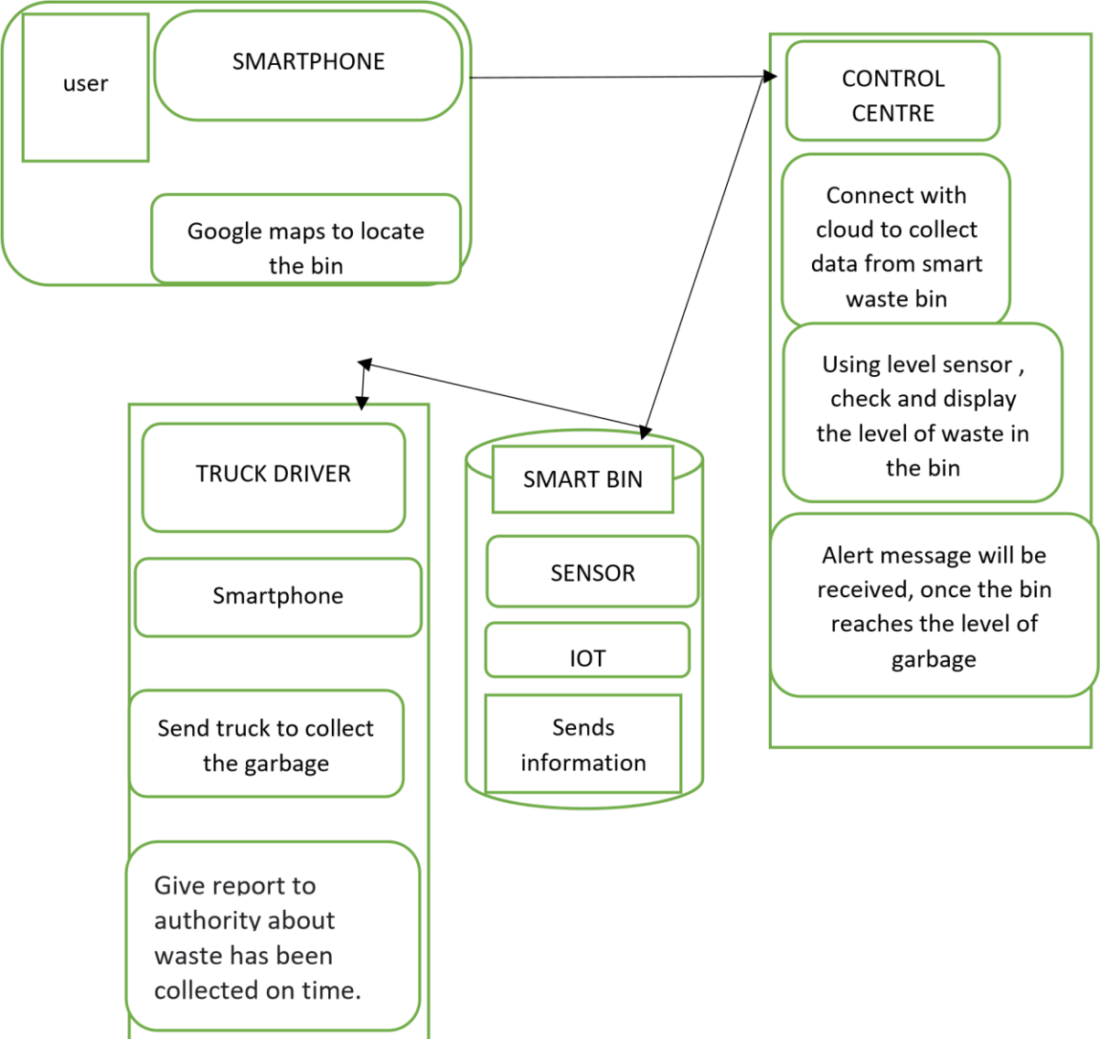

* 1. **Solution & Technical Architecture:**

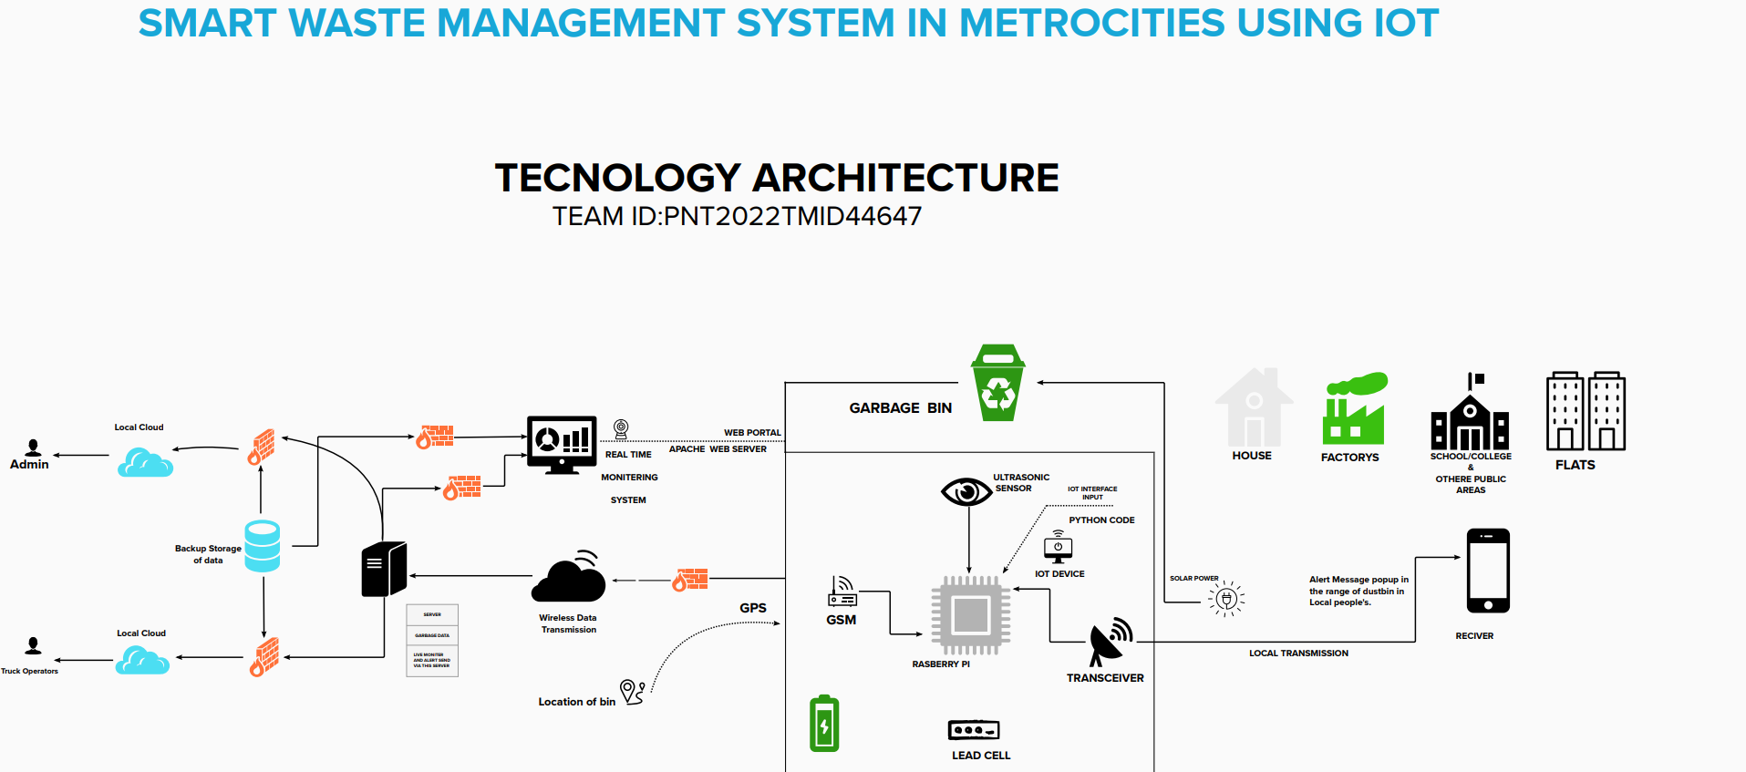

* 1. **User stories:**

|  |  |  |  |  |  |  |
| --- | --- | --- | --- | --- | --- | --- |
| **User Type** | **Functional Requirement (Epic)** | **User Story Number** | **User Story / Task** | **Acceptance criteria** | **Priority** | **Release** |

|  |  |  |  |  |  |  |
| --- | --- | --- | --- | --- | --- | --- |
| Admin(who manages  server) | Web server login | USN-1 | As a admin, I can able to track the truck driver name,  id, contact number, location, and also the location of the dustbin. | I can Manage and direct workers through web server | High | Sprint-1 |

|  |  |  |  |  |  |  |
| --- | --- | --- | --- | --- | --- | --- |
| Co-Admin | Login | USN-2 | As a co-admin I’ll monitor the workers, whether the work has been done properly, checking the availability of workers and also monitor the waste collected by the truck driver within the  scheduled time | I can monitor the  garbage bin activity | High | Sprint-1 |
| Customer (Web user) | User | USN-3 | As a user , I can able to raise queries to higher authorities about the maintenance and disposal of waste | I can raise queries | Medium | Sprint-2 |
| Customer Care Executive | Worker | USN-4 | As a customer care executive I will try to rectify the queries from customers by contacting coadmin. In case of emergency situation query can be reported to Admin. | I can attend calls and respond  people and solve their problems | High | Sprint-1 |

|  |  |  |  |  |  |  |
| --- | --- | --- | --- | --- | --- | --- |
| Truck driver | Worker | USN-5 | The truck driver is a  worker who has been assigned to collect the garbage and he have to report  to admin about when and where  and also the  timings , the garbage has been picked up according the  daily schedule. | I will do the work properly and report the data at the scheduled time | High | Sprint1 |

# PROJECT PLANNING & SCHEDULING:

## Sprint Planning & Estimation:

|  |  |  |  |  |  |  |
| --- | --- | --- | --- | --- | --- | --- |
| **Sprint** | **Functional**  **Requirement (Epic)** | **User Story Number** | **User Story / Task** | **Story Points** | **Priority** | **Team**  **Members** |
| Sprint-1 | Login | USN-1 | As a Administrator, I need to give user id and passcode for ever workers over there in municipality | 10 | High | Karthick |
| Sprint-1 | Login | USN-2 | As a Co-Admin, I’ll control the waste level by monitoring them vai real time web portal. Once the filling happens, I’ll notify trash truck with location of bin with bin ID | 10 | High | Chandru |
| Sprint-2 | Dashboard | USN-3 | As a Truck Driver, I’ll follow Co-Admin’s  Instruction to reach the filling bin in short roots and save time | 20 | Low | yuvaraj |
| Sprint-3 | Dashboard | USN-4 | As a Local Garbage Collector, I’II gather all the waste from the garbage, load it onto a garbage truck, and deliver it to Landfills | 20 | Medium | Sakthivel |
| Sprint-4 | Dashboard | USN-5 | As a Municipality officer, I'll make sure everything is proceeding as planned and without any problems | 20 | High | Dinesh |

**Project Tracker, Velocity & Burndown Chart: (4 Marks)**

|  |  |  |  |  |  |  |
| --- | --- | --- | --- | --- | --- | --- |
| **Sprint** | **Total Story Points** | **Duration** | **Sprint Start Date** | **Sprint End Date (Planned)** | **Story Points**  **Completed (as on**  **Planned End Date)** | **Sprint Release Date (Actual)** |
| Sprint-1 | 20 | 8 Days | 24 Oct 2022 | 02 Nov 2022 | 20 | 02 Nov 2022 |
| Sprint-2 | 20 | 8 Days | 02 Nov 2022 | 10 Nov 2022 | 20 | 10 Nov 2022 |
| Sprint-3 | 20 | 8 Days | 10 Nov 2022 | 18Nov 2022 | 20 | 18 Nov 2022 |
| Sprint-4 | 20 | 8 Days | 18 Nov 2022 | 26 Nov 2022 | 20 | 26 Nov 2022 |
|  |  |  |  |  |  |  |
|  |  |  |  |  |  |  |
|  |  |  |  |  |  |  |
|  |  |  |  |  |  |  |

**Velocity:**

Imagine we have a10-day sprint duration, and the velocity of the team is 20 (points per sprint). Let’s calculate the team’s average velocity (AV) per iteration unit (story points per day)

SPRINT DURATION 20

AV = -------------------------- = ---- = 2 VELOCITY 20

# Reports from JIRA:

### Burnout Chart:

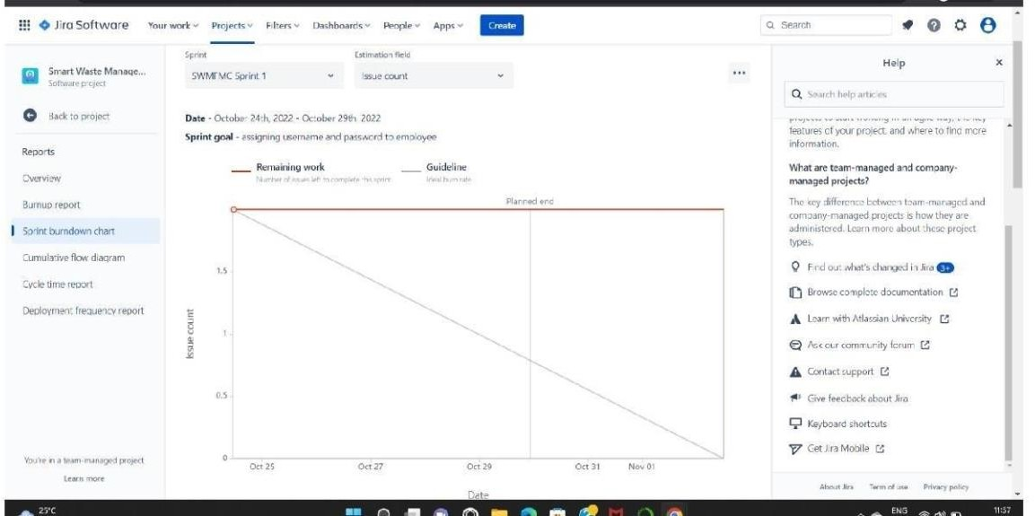

**Road map:**

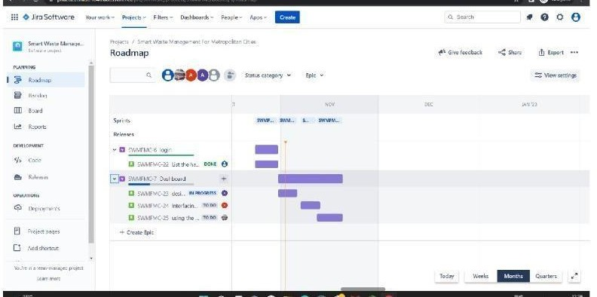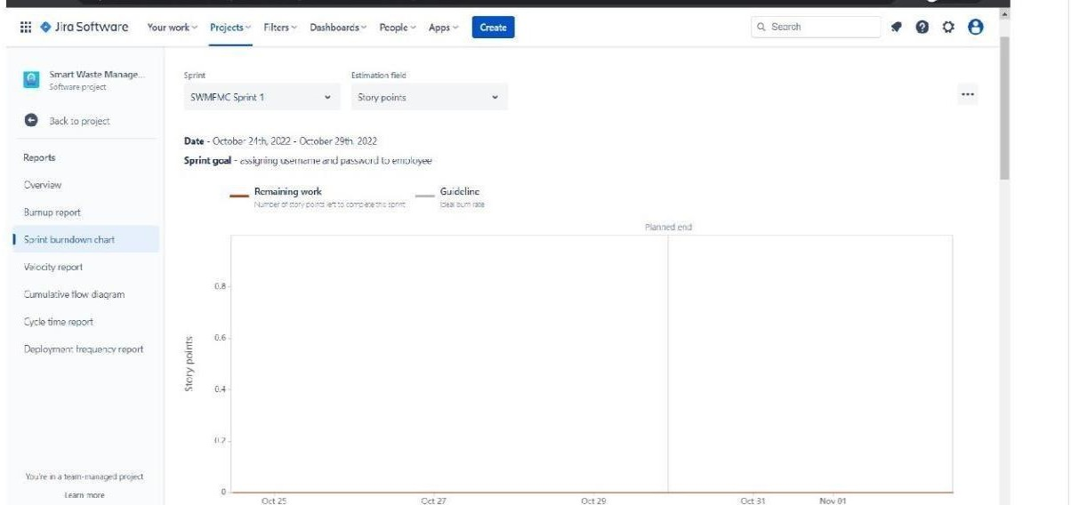

# CODING & SOLUTIONING:

## Feature 1- LOCATION TRACKER:

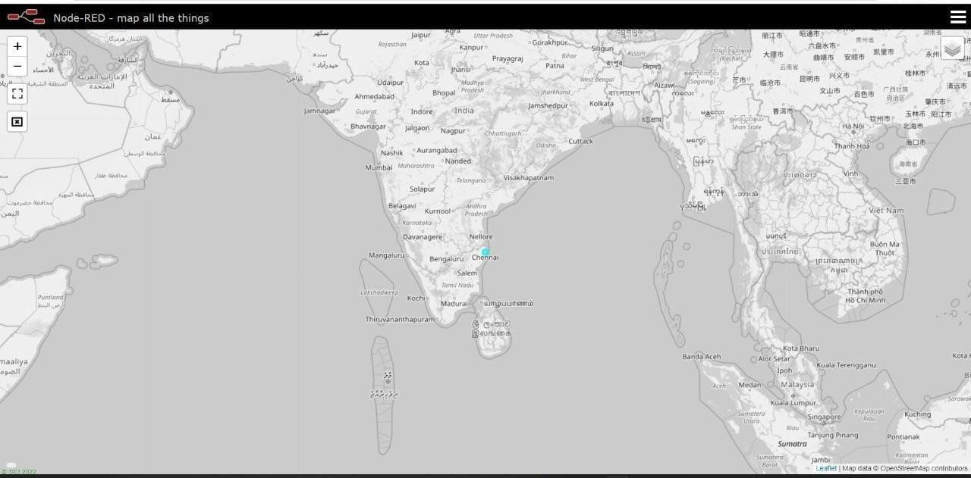

* 1. **Feature 2- LIVE UPDATE ON COLLECTED DATA:**

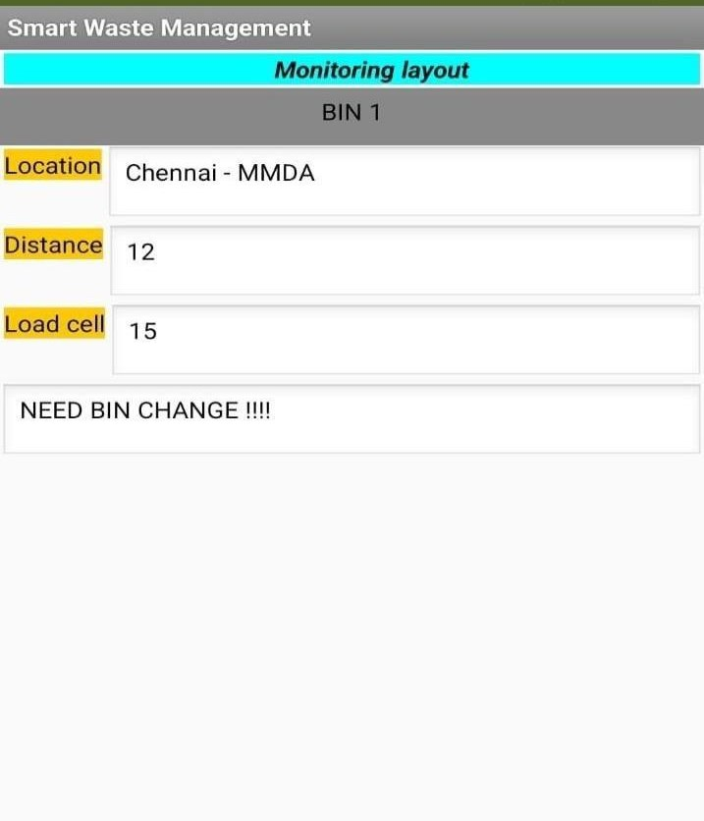

# Testing:

## Testcases:

|  |  |  |  |  |  |  |  |  |  |  |  |  |  |
| --- | --- | --- | --- | --- | --- | --- | --- | --- | --- | --- | --- | --- | --- |
| TEST CASE ID | FEATUR E TYPE | COM PO NENT | TEST SCENARI O | PR ER EQ UIS ITE | STEPS TO EXEC UT  E | TEST DATA | EXPEC TED RESUL T | ACTU AL RESUL T | STAT U S | CO MM ENT S | TC FOR AUTO M ATIO N( Y/N) | BU G ID | EXECUTED BY |
| LOGIN PAGE_TC | FUNCTI ONA L | HOM E | VERIFY THE USER |  | 1.ENT ER | https:// 1 | L0gin page is | Workin g as | PASS | **Suc cess** |  |  | CHANDRU. S |
| _001 |  | PAGE | IS ABLE | URL | 69.51.2 | visible | expecte |  | **ful** |  |
|  |  |  | TO SEE | AND | 0 |  | d |  |  |  |
|  |  |  | THE | CLICK | 4.219.3 |  |  |  |  |  |
|  |  |  | LOGIN/SI | GO | 0 |  |  |  |  |  |
|  |  |  | G | 2.VER | 106 |  |  |  |  |  |
|  |  |  | N UP | IFY |  |  |  |  |  |  |
|  |  |  | WEN | LOGI |  |  |  |  |  |  |
|  |  |  | USER | N/SI |  |  |  |  |  |  |
|  |  |  | CLICK ON | GN |  |  |  |  |  |  |
|  |  |  | MY | UP |  |  |  |  |  |  |
|  |  |  | ACCOUNT |  |  |  |  |  |  |  |
|  |  |  | BUTTON |  |  |  |  |  |  |  |

|  |  |  |  |  |  |  |  |  |  |  |  |  |  |
| --- | --- | --- | --- | --- | --- | --- | --- | --- | --- | --- | --- | --- | --- |
| LOGIN PAGE_TC  _002 | UI | HOM E PAGE | VERIFY THE USER IS ABLE TO SEE THE LOGIN/SI G  N UP WEN USER CLICK ON MY ACCOUNT BUTTON |  | 1.ENT ER URL AND CLICK GO 2.VER IFY LOGI N/SI GN UP  Eleme  nts a.ID  text  b o x  B  .  passw ord text box c..logi n butto n D.ne w user E.alre ady have an accou nt | https:// 1  69.51.2  0  4.219.3  0  106 | Applicat ion should show below UI  elemen t | Workin g as expecte d | PASS | Succ ess ful**l** |  |  | YUVARAJ. M |

|  |  |  |  |  |  |  |  |  |  |  |  |  |  |
| --- | --- | --- | --- | --- | --- | --- | --- | --- | --- | --- | --- | --- | --- |
| LOGIN PAGE_TC  _003 | FUNCTI ONA L | LOGI N PAGE | VERIFY THE USER IS ABLE TO SEE THE LOGIN/SI G  N UP WEN USER CLICK ON MY ACCOUNT BUTTON |  | 1.ent er url and click go 2.click on my accou nt 3.Ent er valid ID  4.Ent er valid passw ord 5.click on login | Id:1111  passwo r d:5678 | User should navigat e your home page. | Workin g as expecte d | PASS | Succ ess ful |  |  | SAKTHIVEL.P |
|  |  |  |  |  | butto n |  |  |  |  |  |  |  |  |
| LOGIN | FUNCTI ONA | LOGI N | VERIFY |  | 1.ent er url | Id:1111 | Confirm | Workin | PASS | Succ ess |  |  | DINESH. A |

|  |  |  |  |  |  |  |  |  |  |  |  |  |  |
| --- | --- | --- | --- | --- | --- | --- | --- | --- | --- | --- | --- | --- | --- |
| PAGE_TC_ 004 | L | PAGE | THE USER  IS ABLE TO SEE |  | and click go 2.click on my account 3.Enter valid ID 4.Enter valid password 5.click on login  butvton | pass  wor d:56 | ation message sent | g as expecte d |  | ful |  |  |  |
|  |  |  | THE | 78 |  |  |  |
|  |  |  | LOGIN/SIG |  |  |  |  |
|  |  |  | N UP WEN |  |  |  |  |
|  |  |  | USER |  |  |  |  |
|  |  |  | CLICK ON |  |  |  |  |
|  |  |  | MY |  |  |  |  |
|  |  |  | ACCOUNT |  |  |  |  |
|  |  |  | BUTTON |  |  |  |  |
| LOGIN PAGE_TC_ 005 | UI | LOGIN PAGE | VERIFY THE USER IS ABLE TO SEE THE LOGIN/SIG N UP WEN  USER CLICK ON |  | 1.enter url and click go 2.click on my account 3.Enter valid ID  4.Enter valid | Id:1 111  pass wor d:56 78 | Confirm ation message sent | Workin g as expecte d | PASS | Success ful |  |  | KARTHIK. E |
|  |  |  | MY | password |  |  |  |  |  |
|  |  |  | ACCOUNT | 5.click |  |  |  |  |  |
|  |  |  | BUTTON | on login |  |  |  |  |  |
|  |  |  |  | button |  |  |  |  |  |
| LOGIN | FUNCTIONA | LOGIN | VERIFY |  | 1.enter url and click go 2.click on my account 3.Enter valid ID 4.Enter valid password 5.click on login  button | Id:1 | Custom | Workin | PASS | Success ful |  |  | CHANDRU. S |
| PAGE_TC_ 006 | L | PAGE  FOR ADMIN | THE USER  IS ABLE TO SEE THE LOGIN/SIG N UP WEN | 111  pass wor d:56 78 | er  databas e is visible | g as  expecte d |  |  |
|  |  |  | USER |  |  |  |  |  |
|  |  |  | CLICK ON |  |  |  |  |  |
|  |  |  | MY |  |  |  |  |  |
|  |  |  | ACCOUNT |  |  |  |  |  |
|  |  |  | BUTTON |  |  |  |  |  |

* 1. **User acceptance Testing:**

### 1. Purpose of Document

The purpose of this document is to briefly explain the test coverage and open issues of the [ProductName] project at the time of the release to User Acceptance Testing (UAT).

### 2. Defect Analysis

This report shows the number of resolved or closed bugs at each severity level, and how they were resolved

|  |  |  |  |  |  |
| --- | --- | --- | --- | --- | --- |
| **Resolution** | **Severity 1** | **Severity 2** | **Severity 3** | **Severity 4** | **Subtotal** |
| By Design | 10 | 4 | 2 | 3 | 20 |
| Duplicate | 1 | 0 | 3 | 0 | 4 |
| External | 2 | 3 | 0 | 1 | 6 |
| Fixed | 11 | 2 | 4 | 20 | 37 |

|  |  |  |  |  |  |
| --- | --- | --- | --- | --- | --- |
| Not Reproduced | 0 | 0 | 1 | 0 | 1 |
| Skipped | 0 | 0 | 1 | 1 | 2 |
| Won't Fix | 0 | 5 | 2 | 1 | 8 |
| Totals | 24 | 14 | 13 | 26 | 7 |

### 1. Test Case Analysis:

This report shows the number of test cases that have passed, failed, and untested

|  |  |  |  |  |
| --- | --- | --- | --- | --- |
| **Section** | **Total Cases** | **Not Tested** | **Fai l** | **Pas s** |
| Print Engine | 7 | 0 | 0 | 7 |

|  |  |  |  |  |
| --- | --- | --- | --- | --- |
| Client Application | 51 | 0 | 0 | 51 |
| Security | 2 | 0 | 0 | 2 |
| Outsource Shipping | 3 | 0 | 0 | 3 |
| Exception Reporting | 9 | 0 | 0 | 9 |
| Final Report Output | 4 | 0 | 0 | 4 |
| Version Control | 2 | 0 | 0 | 2 |

# RESULTS:

* 1. **Performance Metrics:**

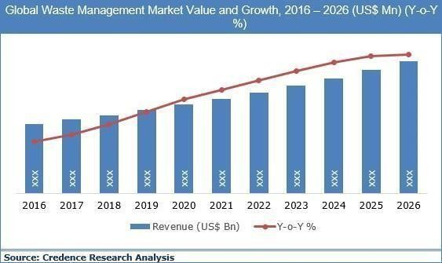

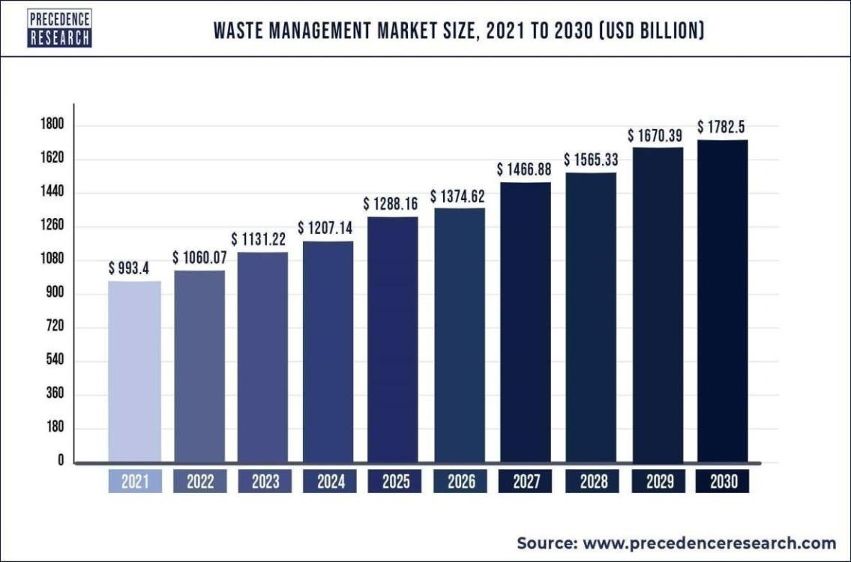

# ADVANTAGES & DISADVANTAGES

## ADVANTAGES:

* Reduction in Collection Cost
* No Missed Pickups
* Reduced Overflows
* Waste Generation Analysis • CO2 Emission Reduction

## DISADVANTAGES:

* System requires a greater number of waste bins for separate waste collection as per population in the city.
* This results into high initial cost due to expensive smart dustbins compare to other methods. Sensor nodes used in the dustbins have limited memory size.

# CONCLUSION:

A Smart Waste Management system that is more effective than the one in use now is achievable by using sensors to monitor the filling of bins. Our conception of a "smart waste management system" focuses on monitoring waste management, offering intelligent technology for waste systems, eliminating human intervention, minimizing human time and effort, and producing a healthy and trash-free environment. The suggested approach can be implemented in smart cities where residents have busy schedules that provide little time for garbage management. If desired, the bins might be put into place in a metropolis where a sizable container would be able to hold enough solid trash for a single unit. The price might be high.

# FUTURE SCOPE:

There are several future works and improvements for the proposed system, including the following:

1. Change the system of user authentication and atomic lock of bins, which would aid in protecting the bin from damage or theft.
2. The concept of green points would encourage the involvement of residents or end users, making the idea successful and aiding in the achievement of collaborative waste management efforts, thus fulfilling the idea of Swachh Bharath.
3. Having case study or data analytics on the type and times waste is collected on different days or seasons, making bin filling predictable and removing the reliance on electronic components, and fixing the coordinates.
4. Improving the Server's and Android's graphical interfaces

# 3. Appendix:

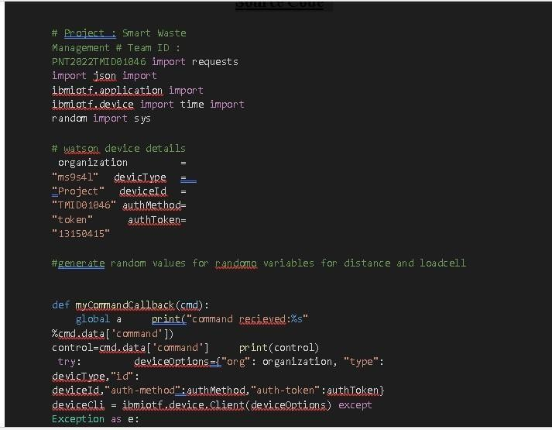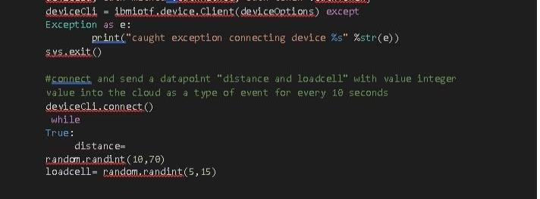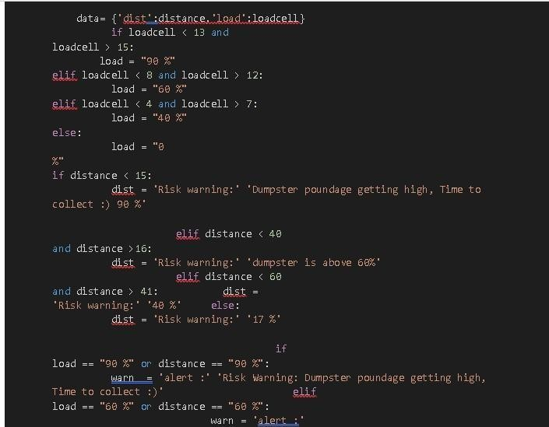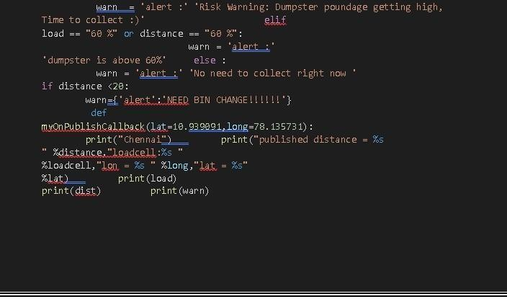

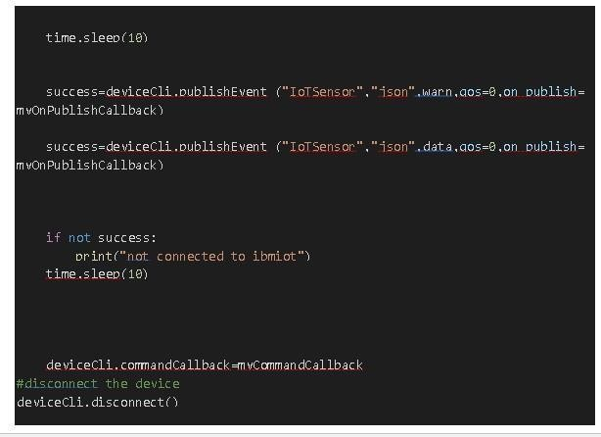

**GitHub Link:**

[https://github.com/IBM-EPBL/IBM-Project-45174-1660728613](https://github.com/IBM-EPBL/IBM-Project-45174-1660728613%0c)

